Travelling from NARITA airport to NIIGATA.
The most straightforward way to travel from Narita Airport to Niigata is by taking the Skyliner train from the airport to Keisi Ueno Station, and taking the Shinkansen (bullet train) from there to Niigata Station.

The two most straightforward ways of travelling from Narita Airport to Niigata are as follows:
Option 1: Take the Skyliner train from Narita to Keisi Ueno Station, change to Uneo (main) Station, then take the Shinkansen (bullet train) from there to Niigata Station.
Option 2: Take the airport bus to Tokyo Station, and then take the Shinkansen to Niigata.

Skyliner route
From Narita Airport Terminal 1 Station follow signs for the Skyliner train [KS]. You will need to buy a ticket from the ticket counter. Please note that although you can purchase tickets from the nearby ticket machines, you also need to make a separate reservation otherwise the ticket is not valid. It is much easier to do this at the counter!
The train will take approximately 45 minutes to Keisi Ueno Station (京成上野駅).The station is underground beneath Ueno Park. To leave the station you will need to put your ticket in the ticket barrier. It is then around 5–10 minutes walk to Ueno Station (上野駅) which is a different train station. It is well signposted from Keisi Ueno Station, and any member of staff will happily point you in the correct direction.

Bus route
From whichever terminal you arrive at follow signs to the buses (バス). There is a ticket machine outside near the bus stances, or you can enquire at the Information kiosk. The bus usually leaves from platform 7 (from Terminal 1) or platform 6 (Terminal 2), and tickets should cost 1500 JPY. You will want to catch the AIRPORT BUS TYO-NRT: timetables are available here https://tyo-nrt.com/en/timetable/to-tokyo.
The bus will stop at Tokyo Station (東京駅) Nihonbashi Entrance (日本橋).

Buying a Shinkansen ticket.
Whether you are at Ueno Station or Tokyo Station, the steps are essentially the same.

First, find a ticket machine that has 新幹線 written on it (feel free to ask a member of staff): 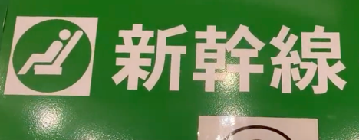

The vending machine will have a sign like this:
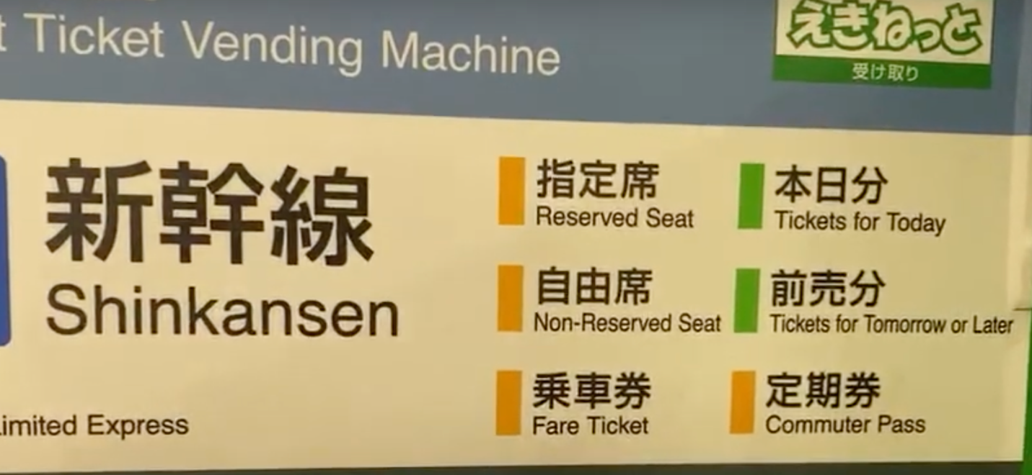
You want to buy Tickets for Today.

First things first, the touchscreen is probably in Japanese, so change it to English:
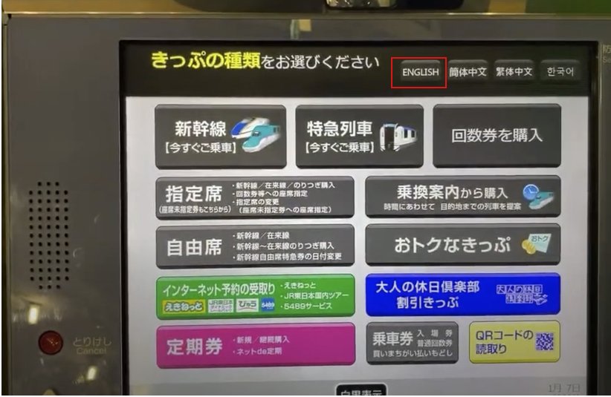

Next, select “Reserved Seat”:
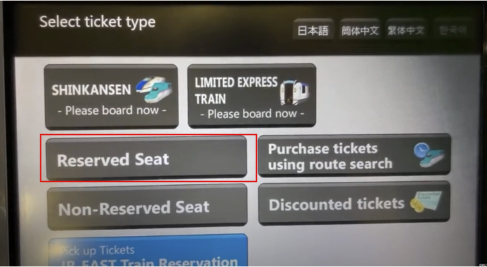
Then, “For seat reservation on Shinkansen”

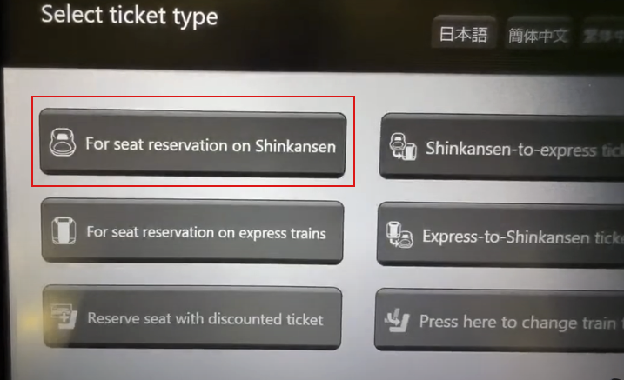
You will have to select the “Joetsu” line:

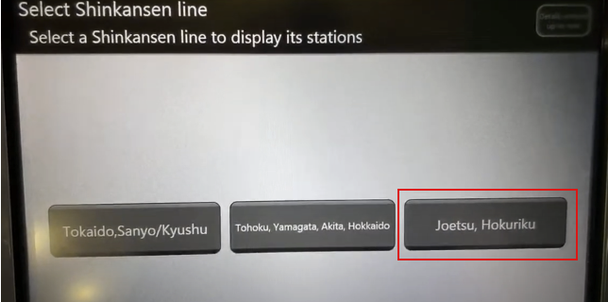
This will take you to a confirmation screen that says “From Tokyo” or “From Ueno” (depending which station you are at): tap this to reach another screen with all the available stations on the Joetsu shinkansen line. Find on the button that says NIIGATA. You will then be given an option of whether you want the ticket today, tomorrow, or some other date. Select Today.

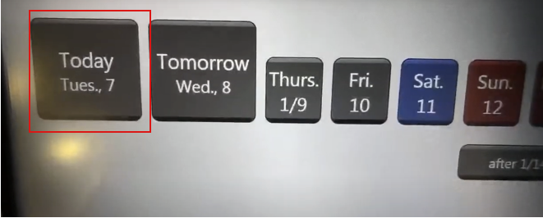

This will then open a screen broken down by hour. Select the most reasonable time for you, bearing in mind you will have to traverse the station.

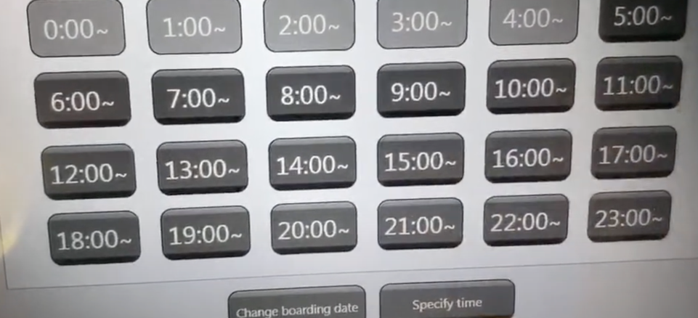

Specify the passengers:
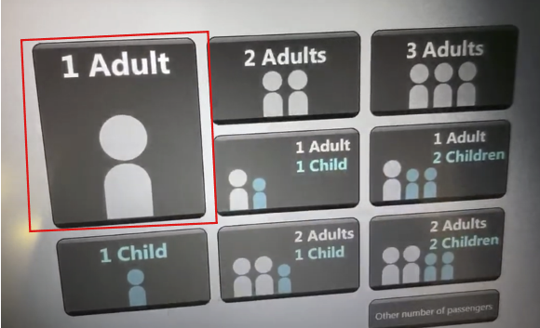

You will then see a list of departure times, so you can choose a specific time. You also have the option of “Ordinary car,” “Green car,” and “Non-reserved seat.” Select the Ordinary car that corresponds to your departure time.
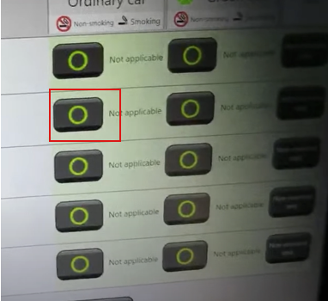
Next you can choose your seat(s) (hit “Select from seat map”). You will get a little graphic of the train, indicating which carriages have the most space:
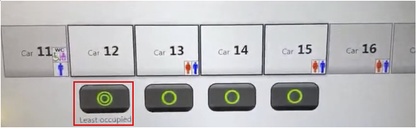
Choose the car, then you can choose your specific seats. On a clear day, you can get a nice view of Mt Fuji as you leave Tokyo from the left-hand-side window seat.
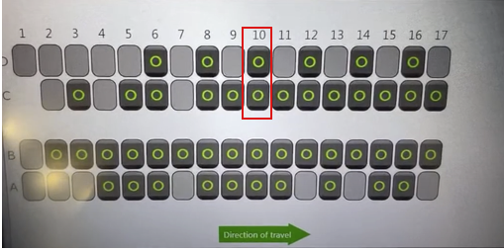
Once you select seats, there will be a couple more confirmation screens, then a payment screen:
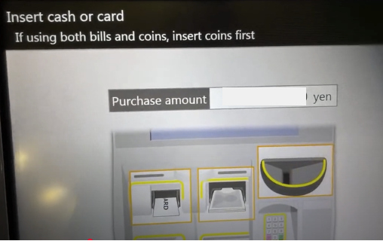

You should receive two tickets. You will need them both to get through the gates. Follow signs towards the Joetsu line shinkansen. Your train will be called “TOKI” followed by a number.
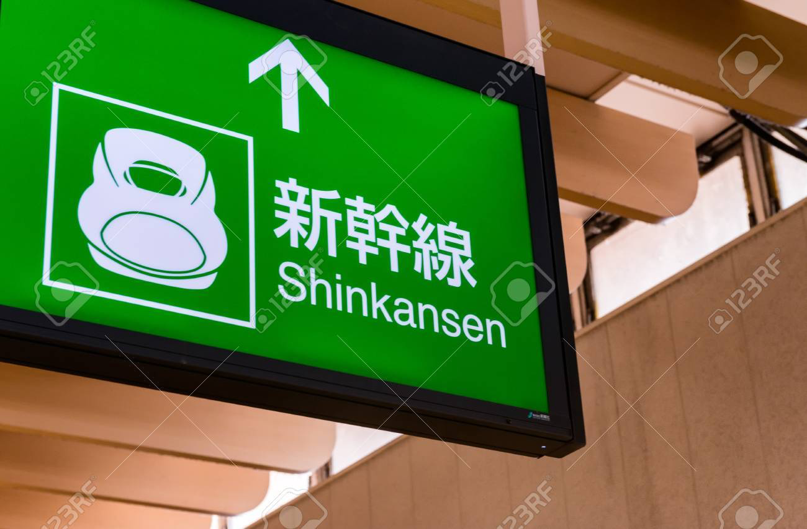
Once you arrive at the platform, you will have to queue up next to your carriage. It will be clearly marked on the ground. When the train arrives, the staff will clean it, turn all the chairs around, and then open the doors about three minutes before departure. The shinkansen very very rarely departs late.

You can buy a lunchbox (“bento”) or beverages in any of the convenience stores in the station, or on board the train itself. There is free wifi on the train too. In under 2 hours, you will be at Niigata Station. Good luck!

