Travelling from HANEDA airport to NIIGATA.

After collecting any baggage, make your way to the Terminal 2 station to catch the Tokyo Monorail [MO] from platform 1 or 2. After about 25 minutes, you want to get off at Hamamatsucho station (浜松町). At Hamamatsucho, transfer onto the green Yamanote Line [JY] bound for Tokyo/Ueno (東京駅). It’s three stops from there to Tokyo Station, which is massive. See instructions below about purchasing tickets. When you approach the ticket barrier for the monorail, insert the ticket into the slot and make sure to collect it again—you will need this when you arrive at Tokyo Station. You shouldn’t need to do anything with it when you transfer from the monorail to Hamamatsucho station.

You will need to find a ticket machine or counter to purchase Shinkansen tickets on the Jōetsu Shinkansen bound for Niigata (新潟). Armed with these, make your way to the Shinkansen part of the train station: if you look lost and show your ticket to any attendant there, they will point you in the right direction. The tickets are in two parts: make sure you put both parts in the ticket gate, otherwise you will not be able to get through.

Buying a monorail ticket
At the airport station, the monorail ticket machine is blue. Not all machines allow payment by credit card, so (unless you have cash on you) check this first. If it doesn’t allow payment by card, you will have to approach the ticket counter instead. If you have cash, follow these steps:
The machine should look like this:
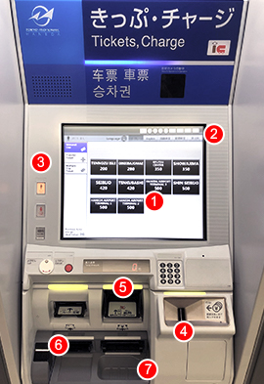 | (1) Touch panel  (2) Screen change (Japanese-English)  (3) Adult/child ticket number button  (4) Coin slot  (5) Bill slot  (6) Ticket slot  (7) Change slot

- Select type of ticket
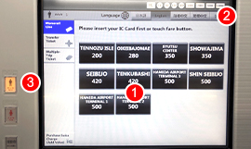
Touch the destination or ticket type shown at (1) on the screen. To change from Japanese to English display, touch the button at (2). For multiple tickets, touch a button at (3) on the left side of the screen before the button for your destination or ticket type. You will need to purchase a ticket from Haneda to Tokyo Station.

- Insert fare
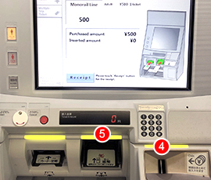
Bills go in the slot, (5) coins in the hopper (4).
- Collect ticket
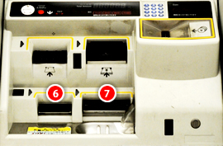
Don’t forget your ticket (6) and change (7)!

Buying a Shinkansen ticket

At Tokyo station, you will have to buy a ticket on the bullet train (shinkansen). Find a ticket machine that has 新幹線 written on it: 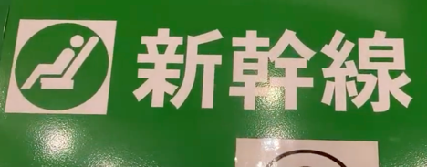

The vending machine will have a sign like this:
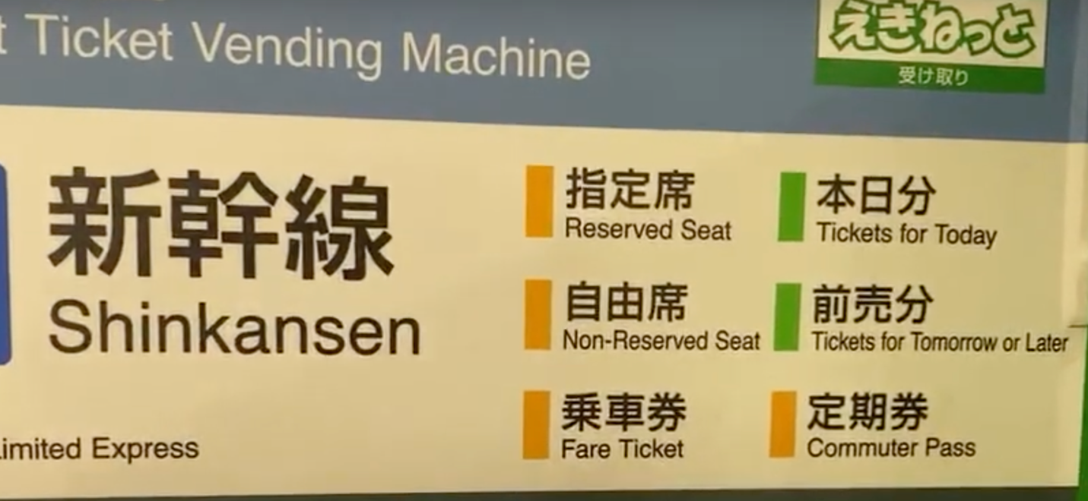
You want to buy Tickets for Today.

First things first, the touchscreen is probably in Japanese, so change it to English:
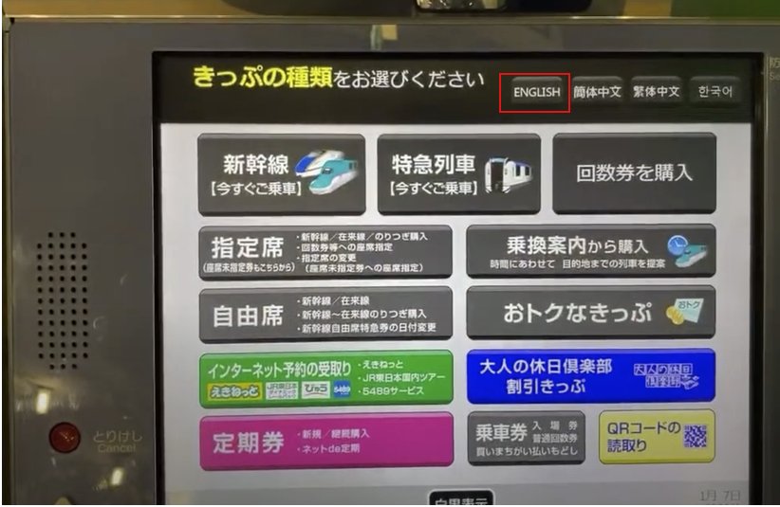

Next, select “Reserved Seat”:
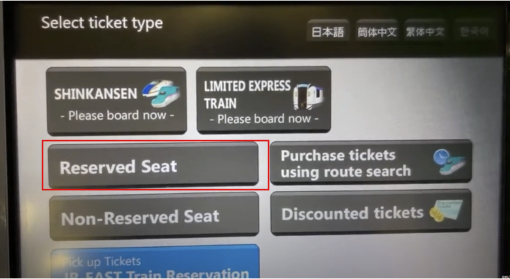
Then, “For seat reservation on Shinkansen”

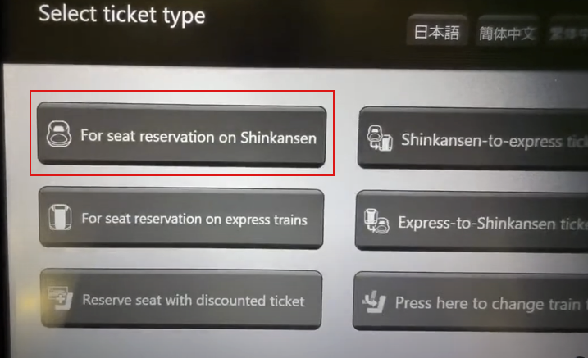
You will have to select the “Joetsu” line:

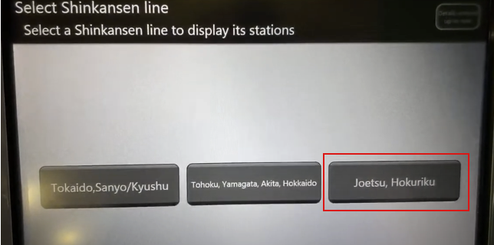
This will take you to a confirmation screen that says “From Tokyo”: tap this to reach another screen with all the available stations on the Joetsu shinkansen line. Find on the button that says NIIGATA. You will then be given an option of whether you want the ticket today, tomorrow, or some other date. Select Today.

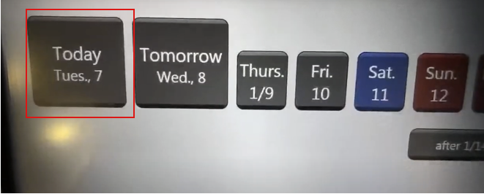

This will then open a screen broken down by hour. Select the most reasonable time for you, bearing in mind you will have to traverse the station.

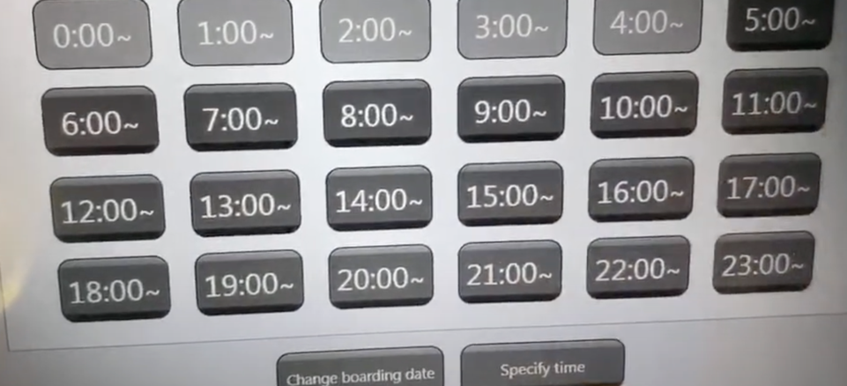

Specify the passengers:
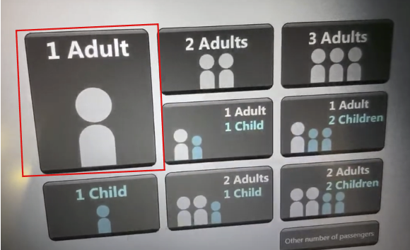

You will then see a list of departure times, so you can choose a specific time. You also have the option of “Ordinary car,” “Green car,” and “Non-reserved seat.” Select the Ordinary car that corresponds to your departure time.
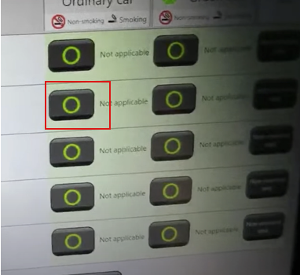
Next you can choose your seat(s) (hit “Select from seat map”). You will get a little graphic of the train, indicating which carriages have the most space:
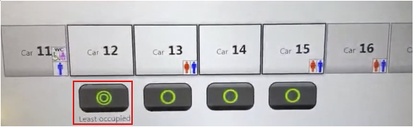
Choose the car, then you can choose your specific seats. On a clear day, you can get a nice view of Mt Fuji as you leave Tokyo from the left-hand-side window seat.
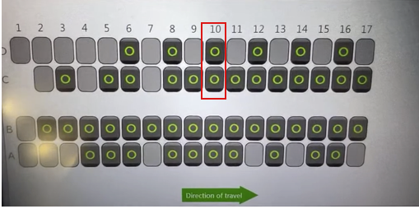
Once you select seats, there will be a couple more confirmation screens, then a payment screen:
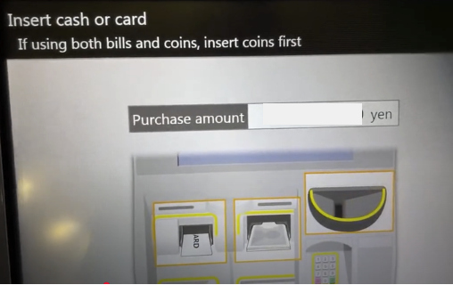

You should receive two tickets. You will need them both to get through the gates. Follow signs towards the Joetsu line shinkansen. Your train will be called “TOKI” followed by a number.
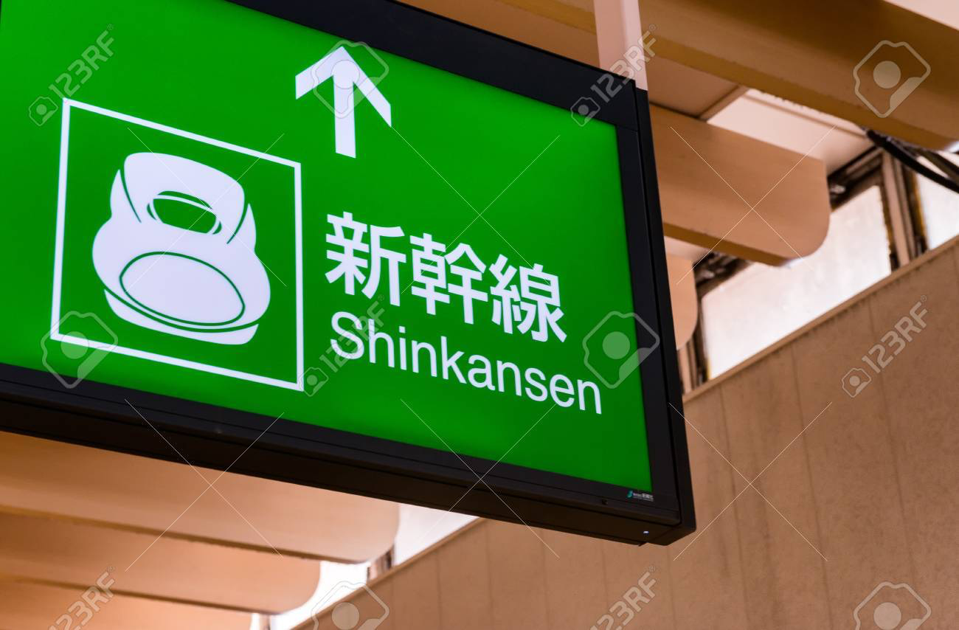
Once you arrive at the platform, you will have to queue up next to your carriage. It will be clearly marked on the ground. When the train arrives, the staff will clean it, turn all the chairs around, and then open the doors about three minutes before departure. The shinkansen very very rarely departs late.

You can buy a lunchbox (“bento”) or beverages in any of the convenience stores in the station, or on board the train itself. There is free wifi on the train too. In under 2 hours, you will be at Niigata Station. Good luck!

